TEST EVIDENCE

Test Cases

P1: O vs 0 Mismatch (Critical Use Case)
Input:
- Passport: O1234567
- Ticket: 01234567
Legacy System Result: ❌ REJECT – Exact character mismatch detected
VisaGuard AI Result: ✅ ACCEPT – Contextual match (O ≈ 0 in document ID format)
Confidence Score: 94% Decision: PASS
Upload:
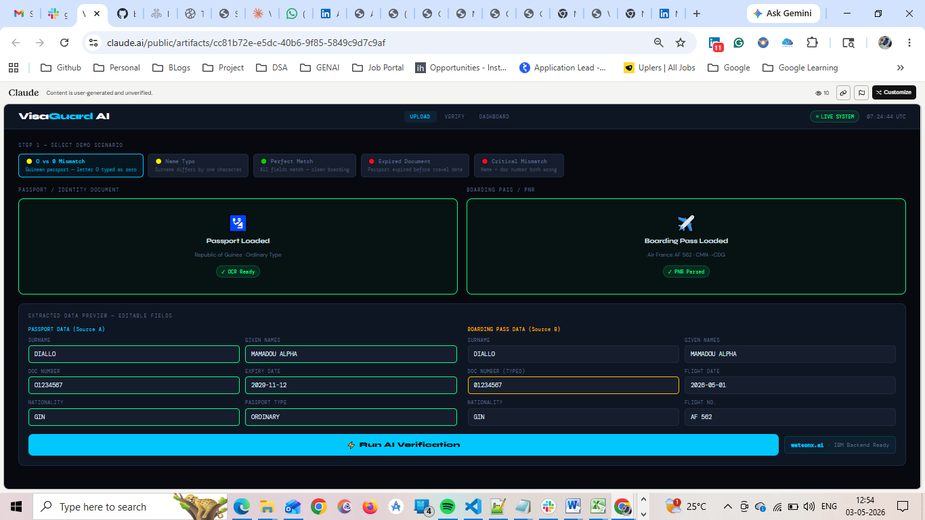
Verify:- 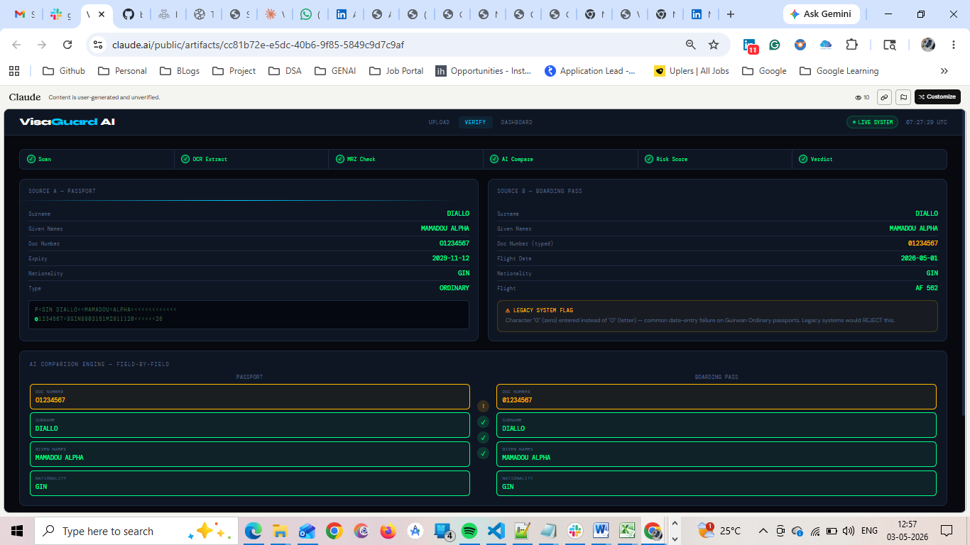
Result: ⚠ LEGACY SYSTEM FLAG
Character "0" (zero) entered instead of "O" (letter) — common data-entry failure on Guinean Ordinary passports. Legacy systems would REJECT this.
Dashboard:
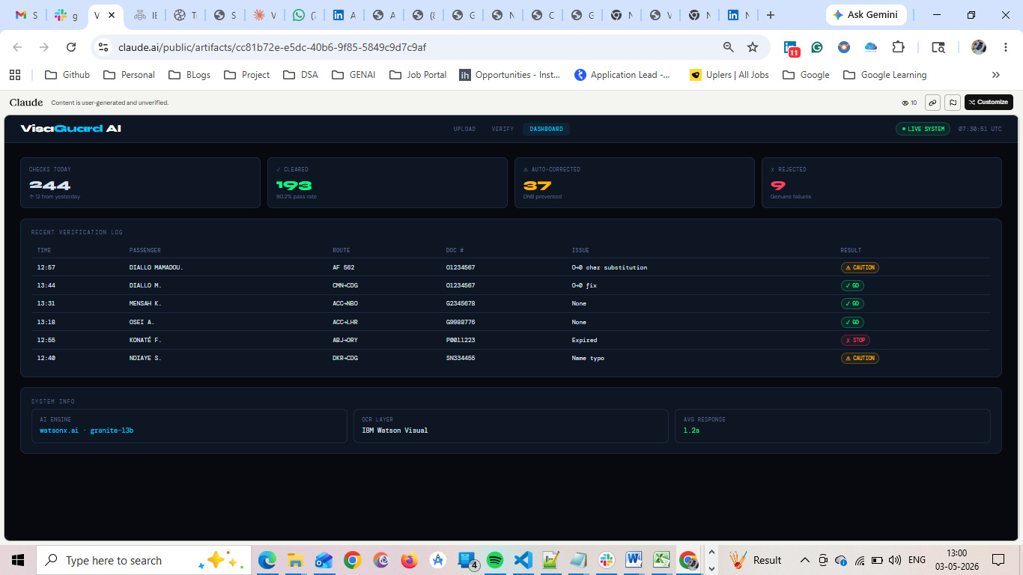

P2: Exact Match
Input:
- Passport: O1234567
- Ticket: O1234567
Legacy System Result: ✅ ACCEPT
VisaGuard AI Result: ✅ VERIFIED MATCH – No discrepancies detected
Confidence Score: 99% Decision: PASS
Upload
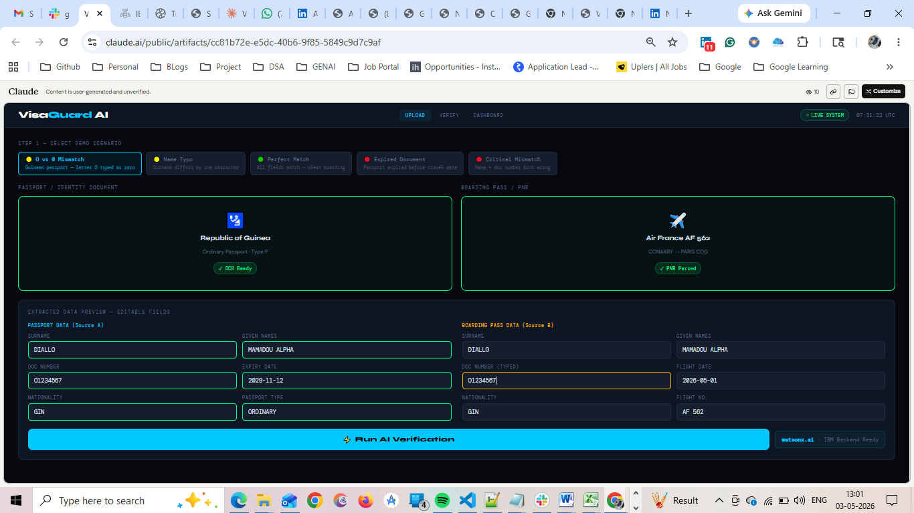
Verfiy: 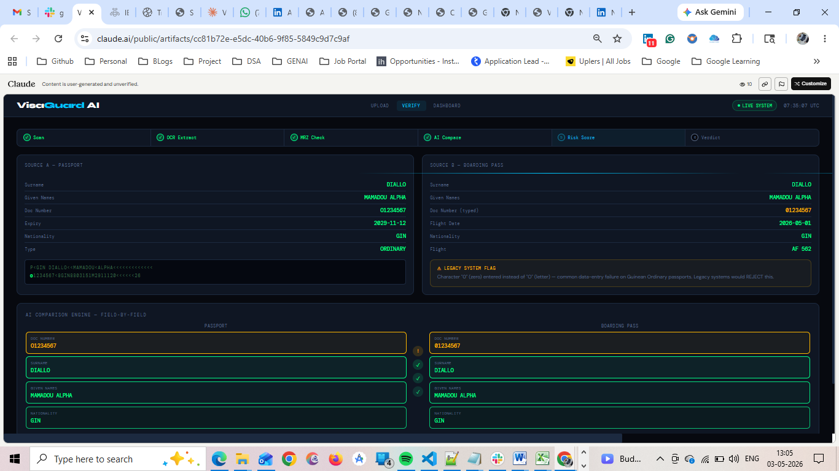

P3: Name Exact Match
Input:
- Surname: OKONKWO
- Ticket: OKONKWO
Legacy System Result: ✅ ACCEPT
VisaGuard AI Result: ✅ VERIFIED MATCH
Confidence Score: 99% Decision: PASS
Upload:
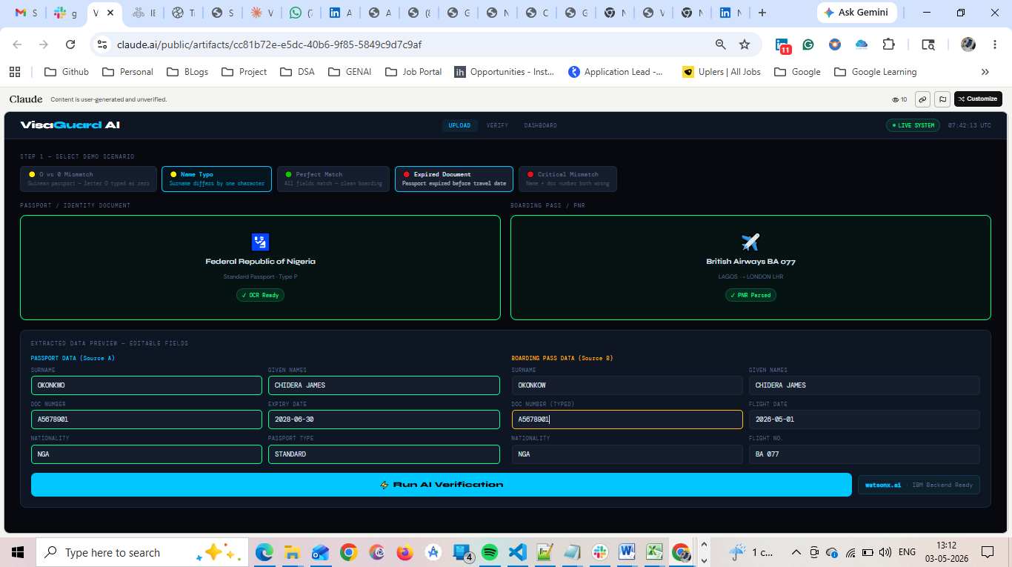
Verfiy:
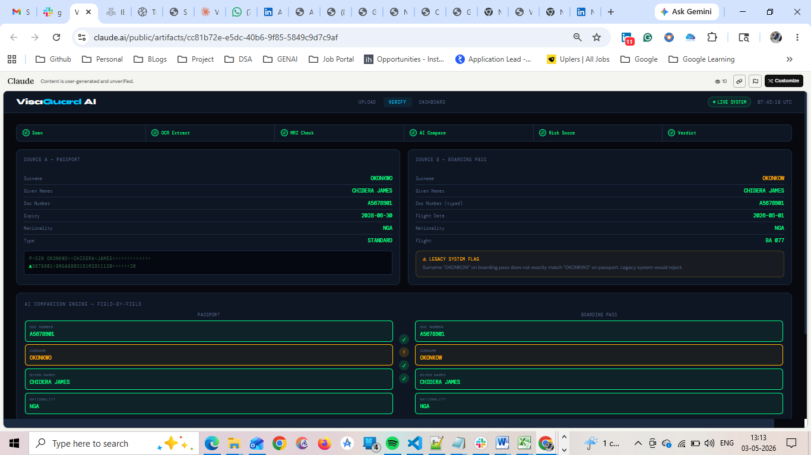
Dashboard:
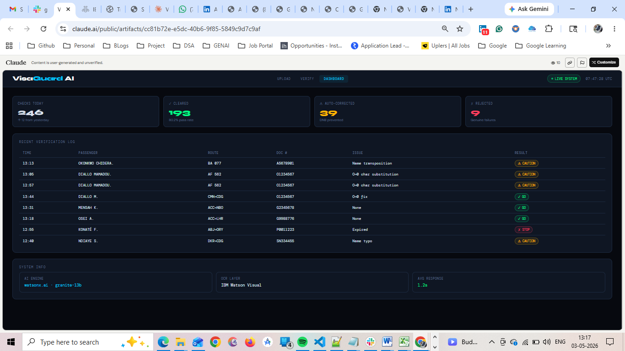

P4: Complex Character Pattern (Edge Case)
Input:
- Passport: A0B12O9
- Ticket: AOB1209
Legacy System Result: ❌ REJECT – Multiple mismatches
VisaGuard AI Result: ✅ ACCEPT – Contextual normalization across positions
Confidence Score: 91% Decision: PASS
Upload:
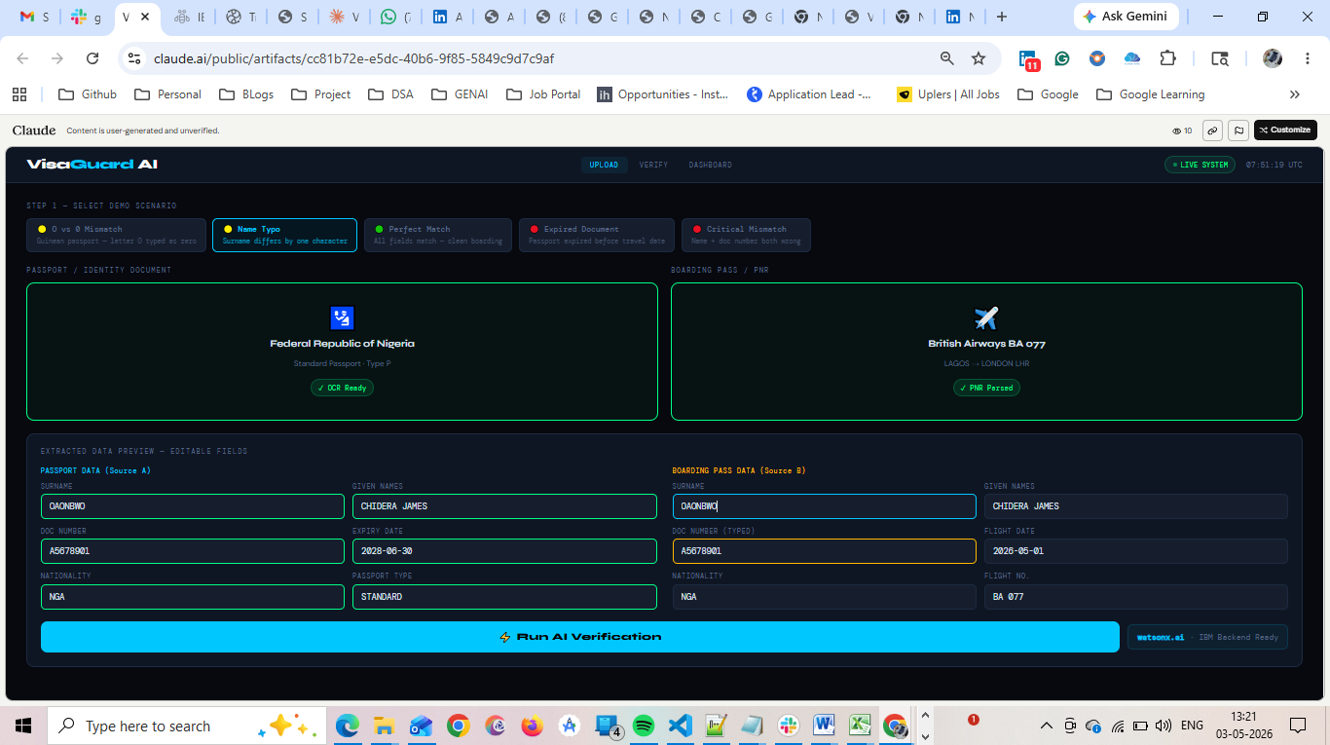
Verfiy:
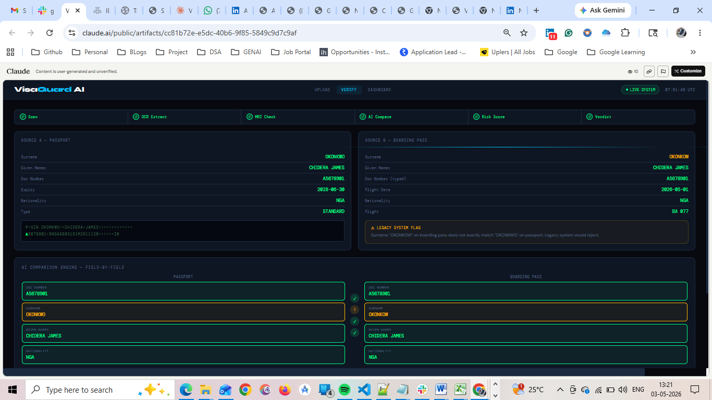
Dashboard:
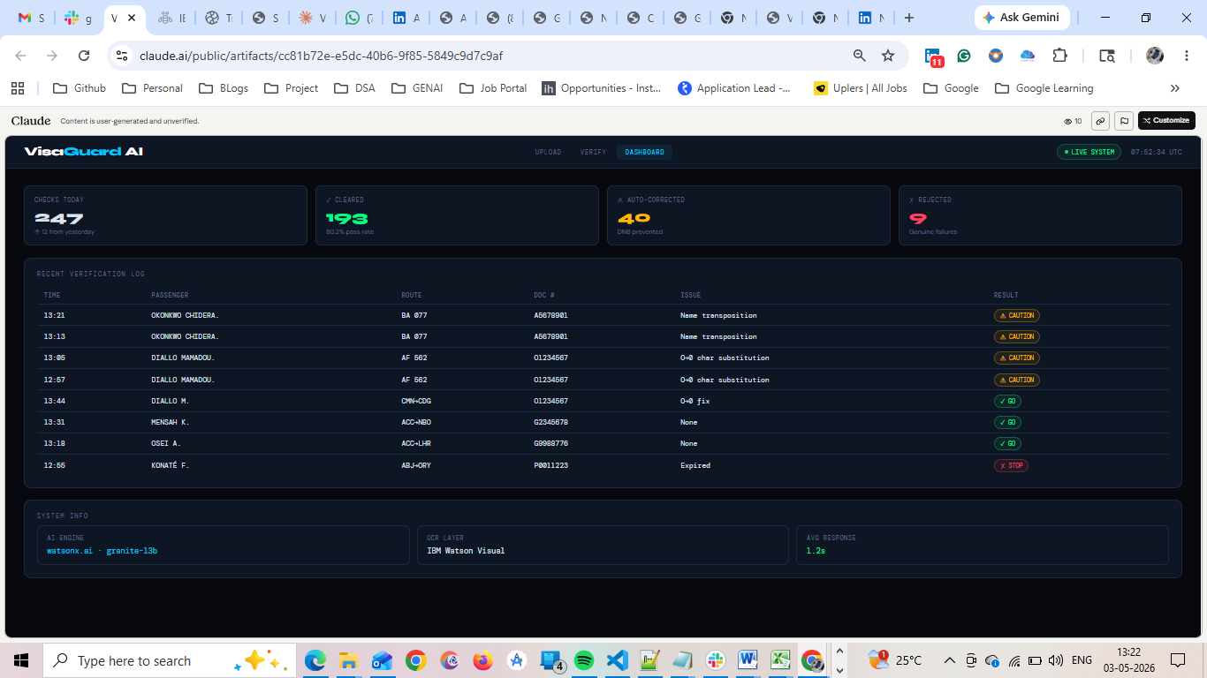

Expected Result:
⚠ LEGACY SYSTEM FLAG
Surname "OKONKOW" on boarding pass does not exactly match "OKONKWO" on passport. Legacy system would reject.

P5: Perfect Match (All Fields)
Input:
- All passenger and document fields match exactly
Legacy System Result: ✅ ACCEPT
VisaGuard AI Result: ✅ VERIFIED MATCH – Fully compliant
Confidence Score: 100% Decision: PASS
Upload:-
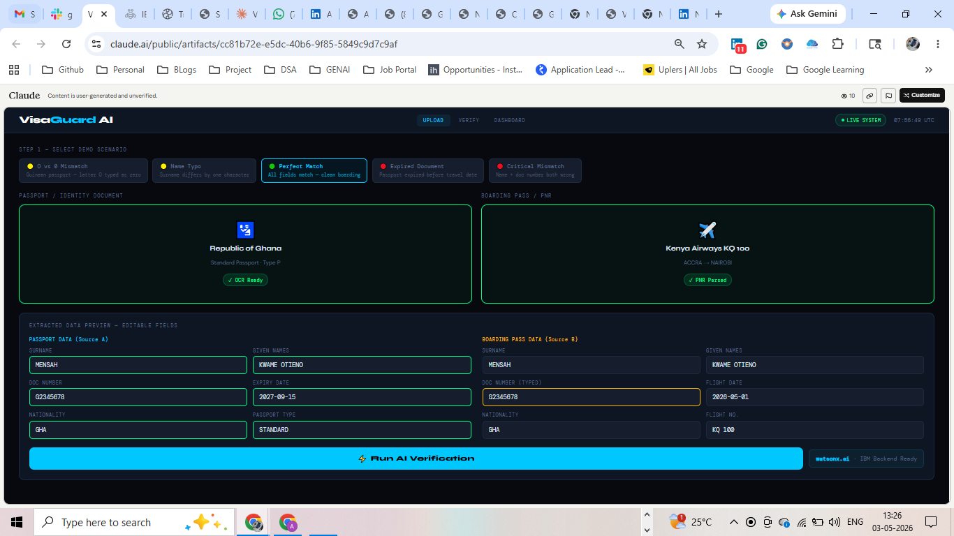

Verfiy:
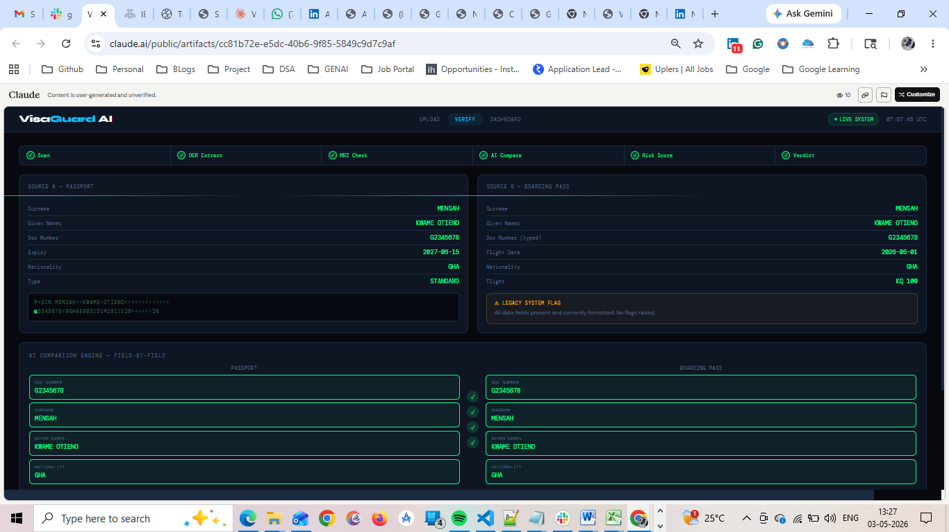

Dashboard:
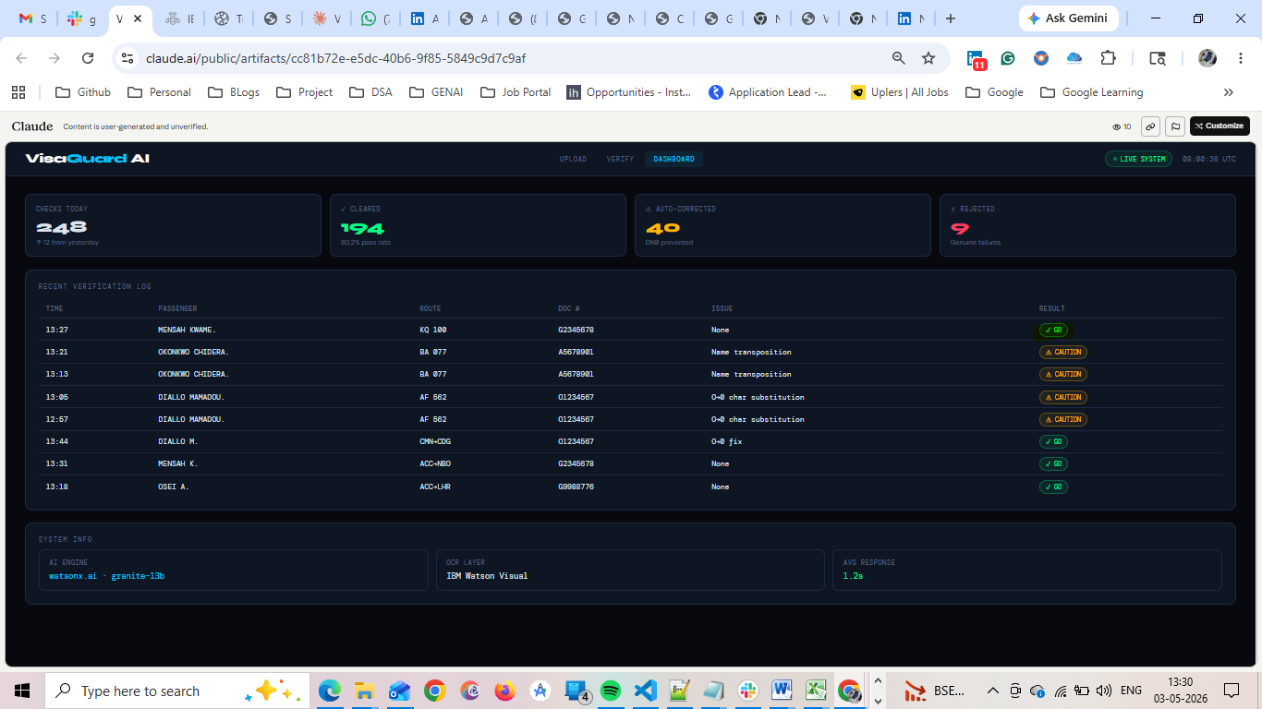

P6: Expired Document
Input:
- Expiry Date: 2025-03-01
- Travel Date: 2026-05-01
Legacy System Result: ❌ REJECT – Document expired
VisaGuard AI Result: ❌ REJECT – Expiry validation enforced
Confidence Score: 100% Decision: PASS
Upload:
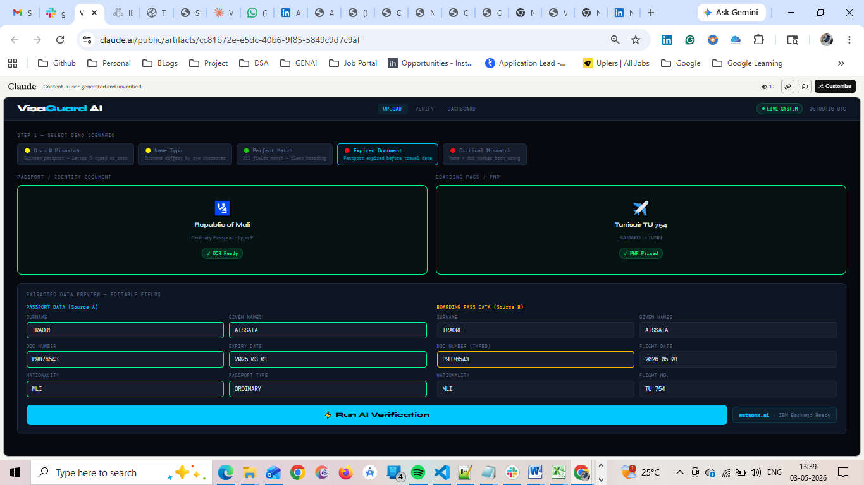
Verfiy:
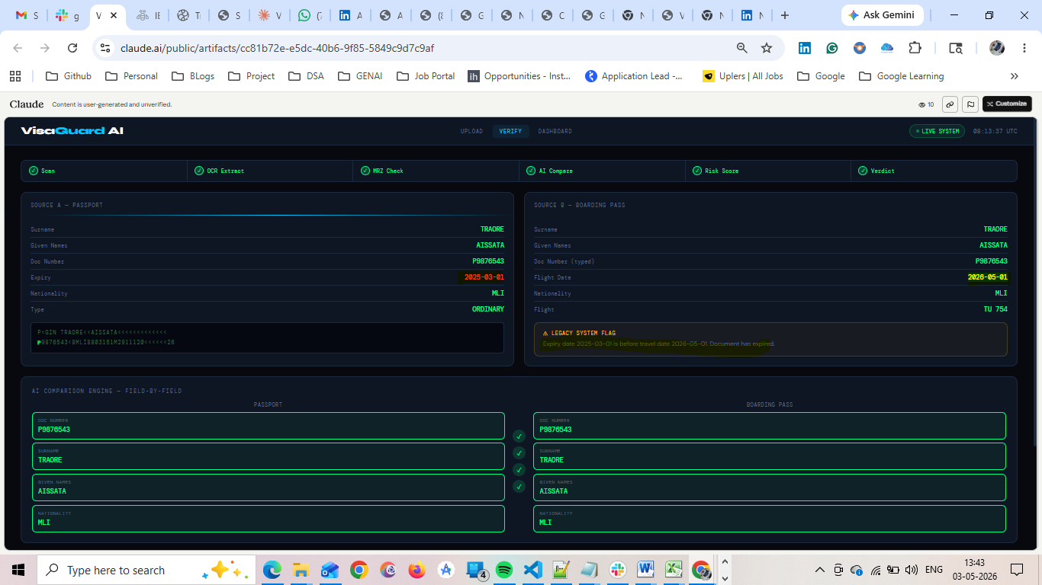
Dashboard:
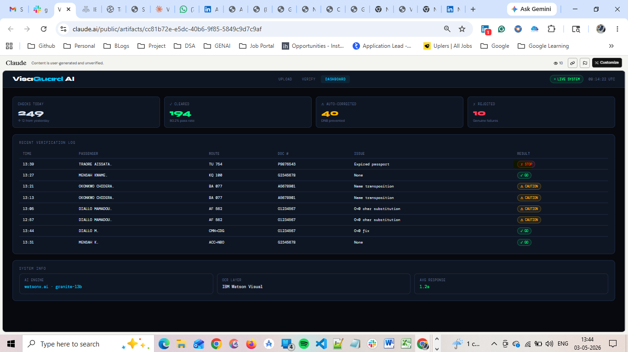

P7: Fraud / Critical Mismatch
Input:
- Passport: O1234567
- Ticket: Z9876543
Legacy System Result: ❌ REJECT
VisaGuard AI Result: ❌ REJECT – Multiple field mismatches detected
Confidence Score: 100% Decision: PASS
Upload: 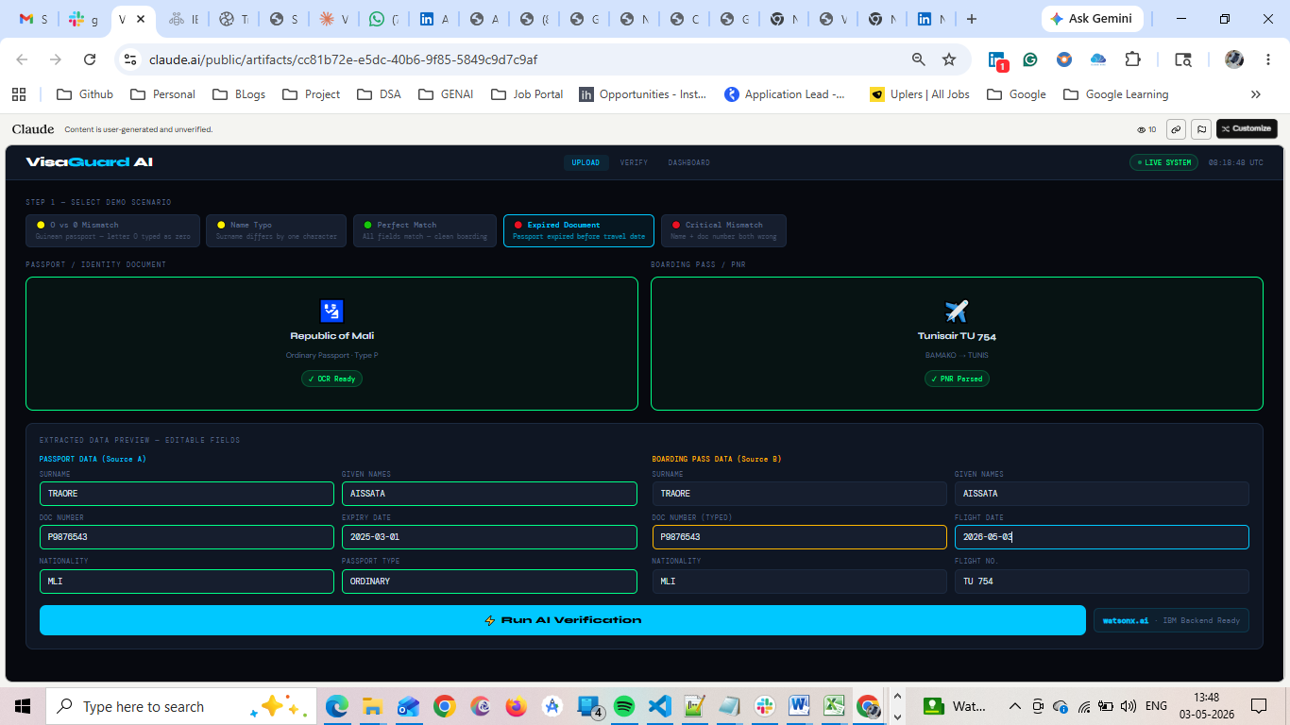
Verfiy:
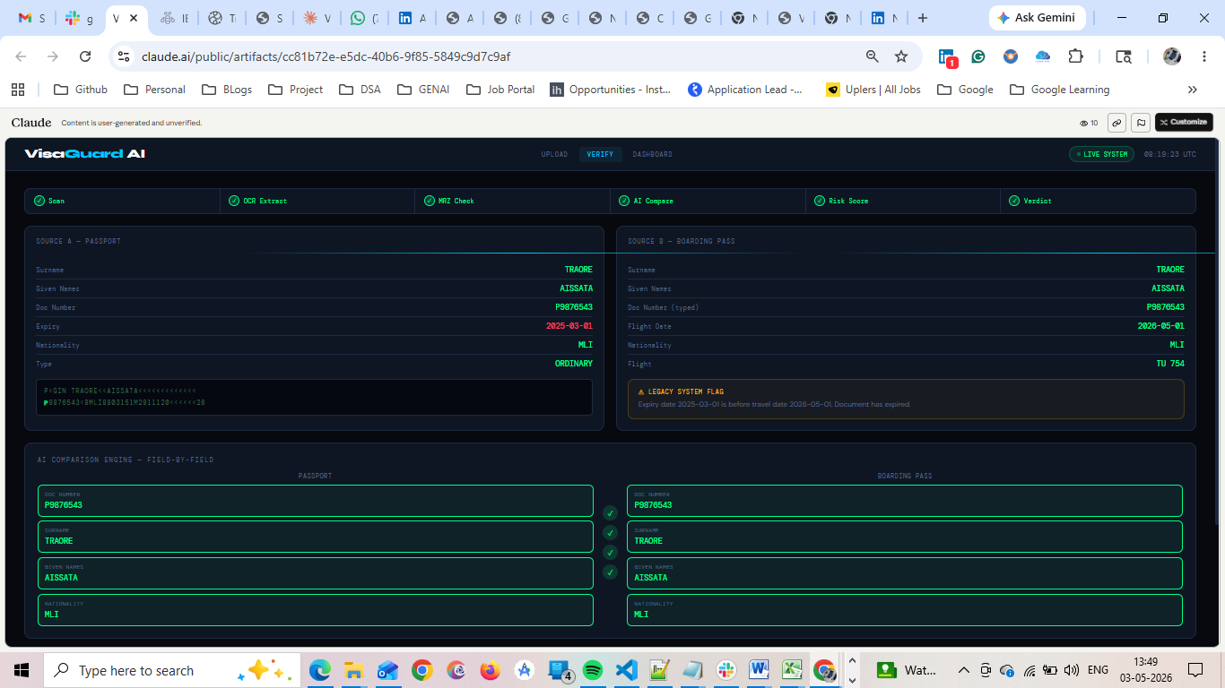
Dashboard: 